# **Experiment Design:**

The Port forwarder was tested in 5 different forms:

* Redirect traffic to SSH
* Redirect traffic to telnet
* Redirect Traffic to an http website
* Redirect traffic to an https website
* Redirect Traffic to an echo server (Multiple Clients)

All tests were run in a LAN network except for the website testing that goes remotely to the WAN.

The port Forwarder use of resources was low as expected.

# **Testing:**

The testing during the implementation of the program was not documented. After completion the forwarder was tested for the 5 cases mentioned above. And some of the test were tested on a pc and Mobile as well.

# **TEST LIST**

|  |  |  |  |  |
| --- | --- | --- | --- | --- |
| Test # | Feature Being Tested | Outcome | Pass / Fail | Figure |
| 1 | Add Rule | Listen for Connections / Apply Rule | Pass | Fig 1,2 |
| 2 | Delete Rule | Close Socket / Remove rule | Pass | Fig 3 |
| 3 | Redirect SSH | Forward traffic as intended | Pass | Fig 4,5,6, |
| 4 | Redirect Telnet | Forward traffic as intended | Pass | Fig 5,7,8 |
| 5 | Redirect http | Forward traffic as intended | Pass | Fig 9,10,11 |
| 6 | Redirect https | Forward traffic as intended | Pass | Fig 12,13,14, |
| 7 | Stress Test | Forward traffic as intended | Pass | Fig 15,16 |

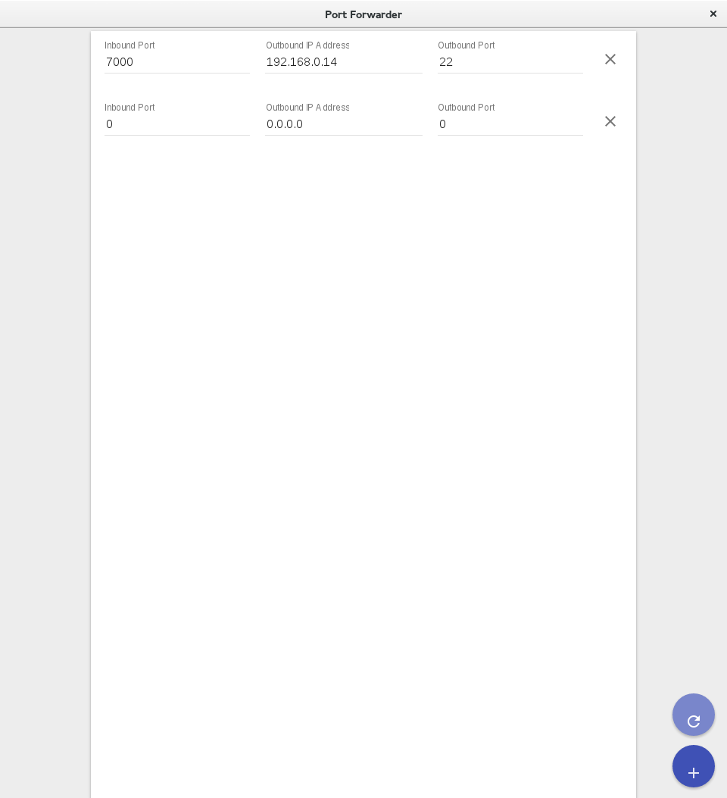

Figure 1

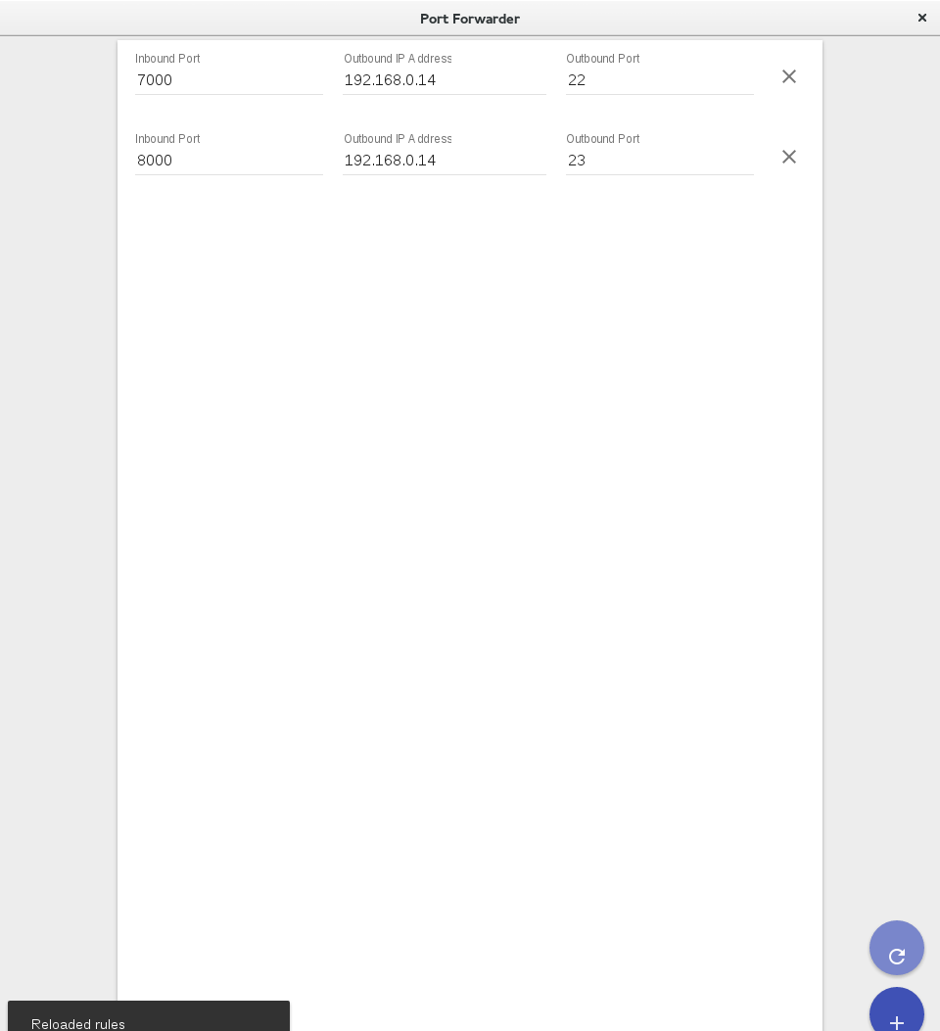

Figure 2

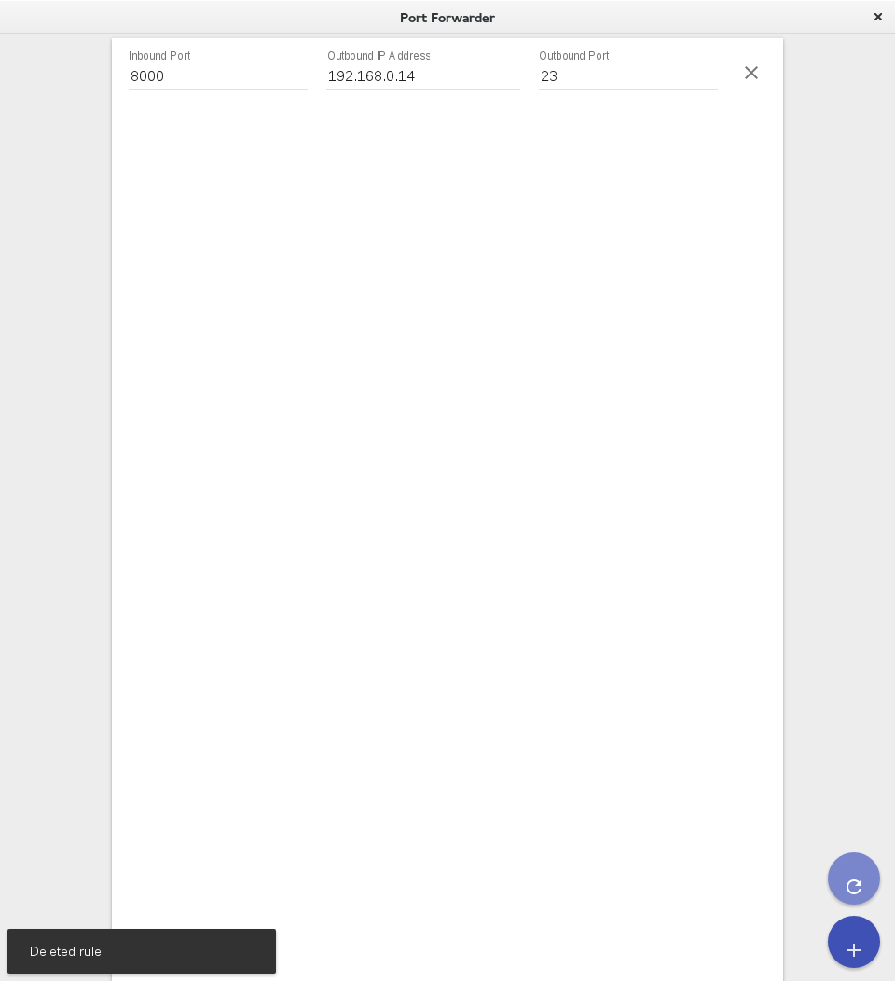

Figure 3

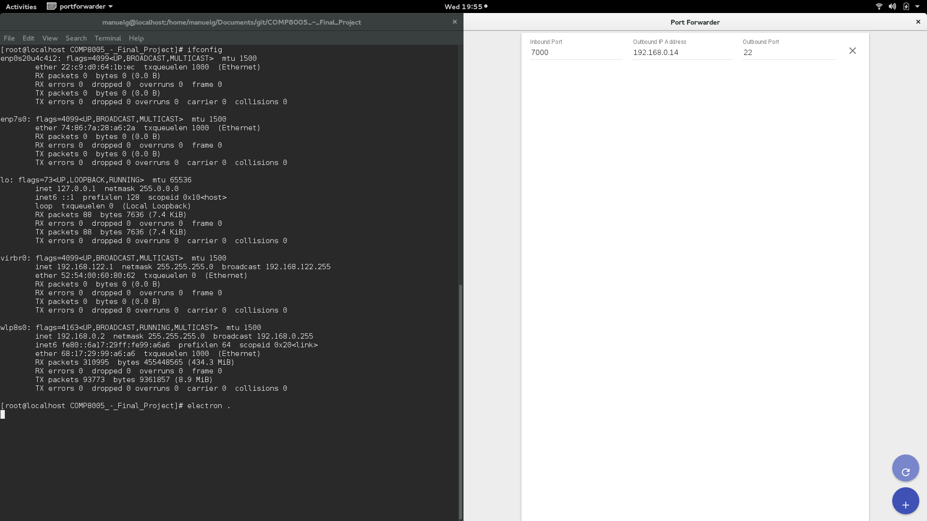

Figure 4

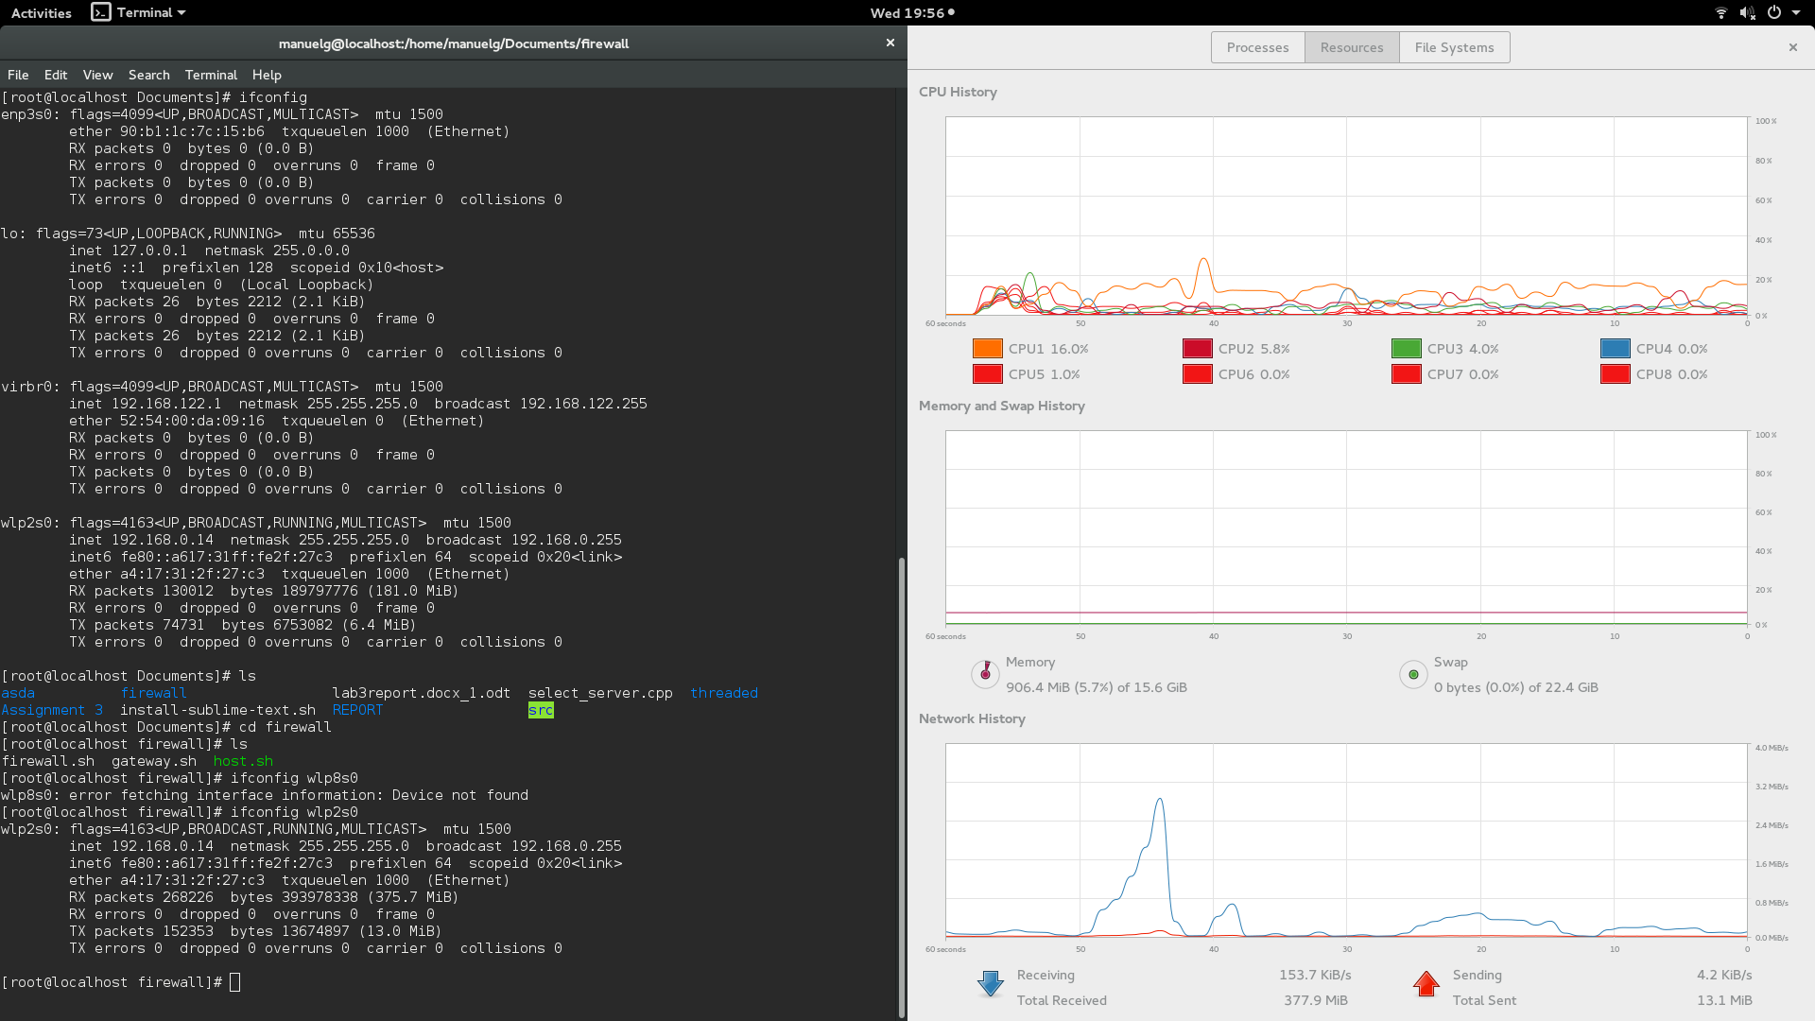

Figure 5

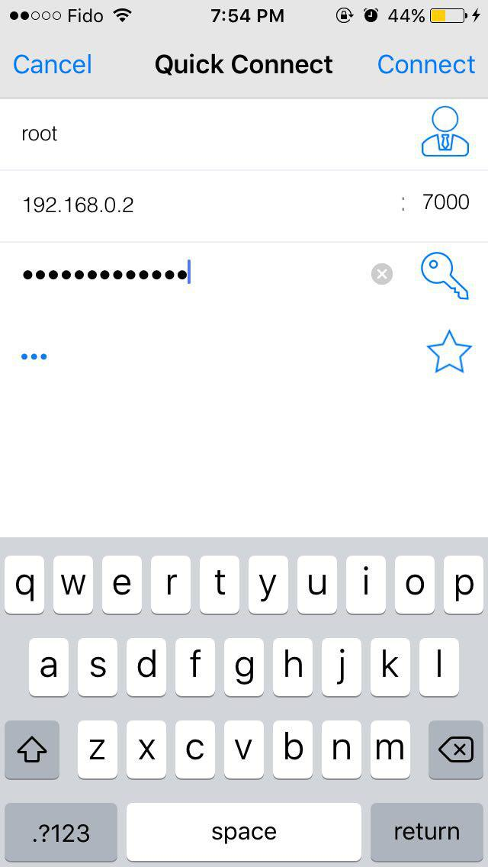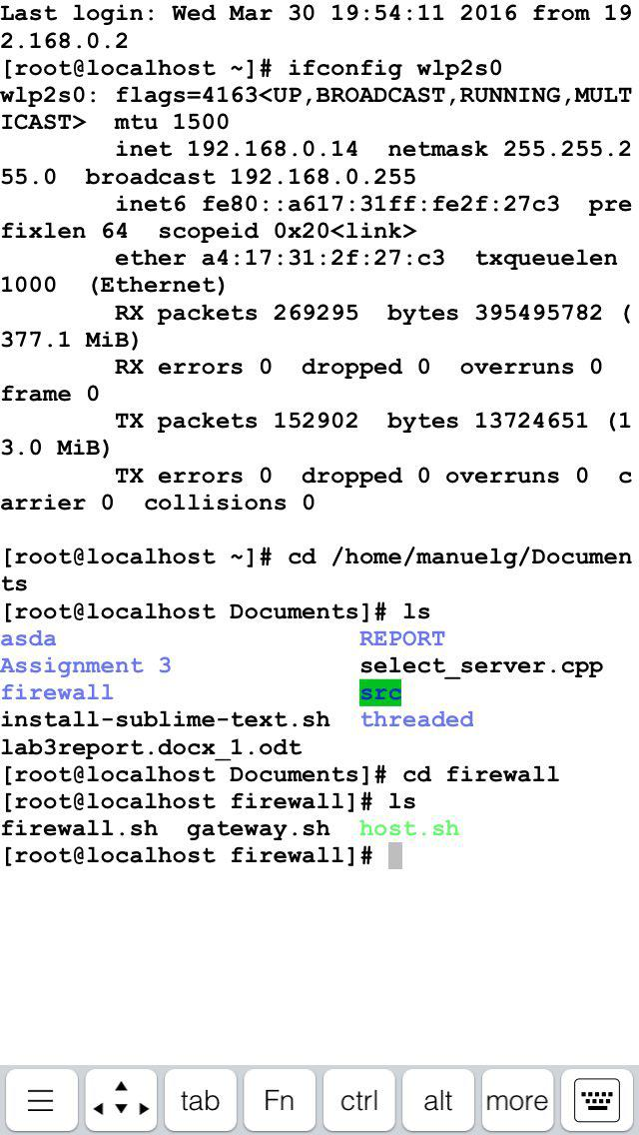

Figure 6

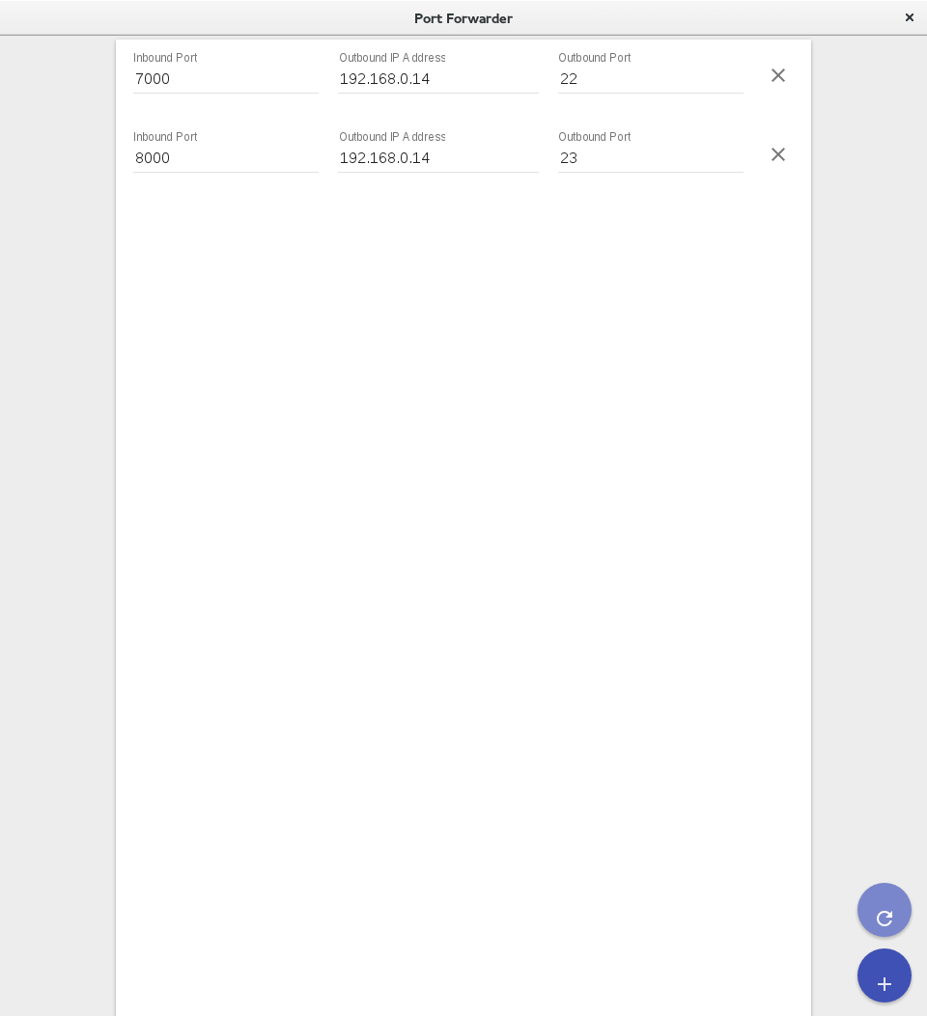

Figure 7

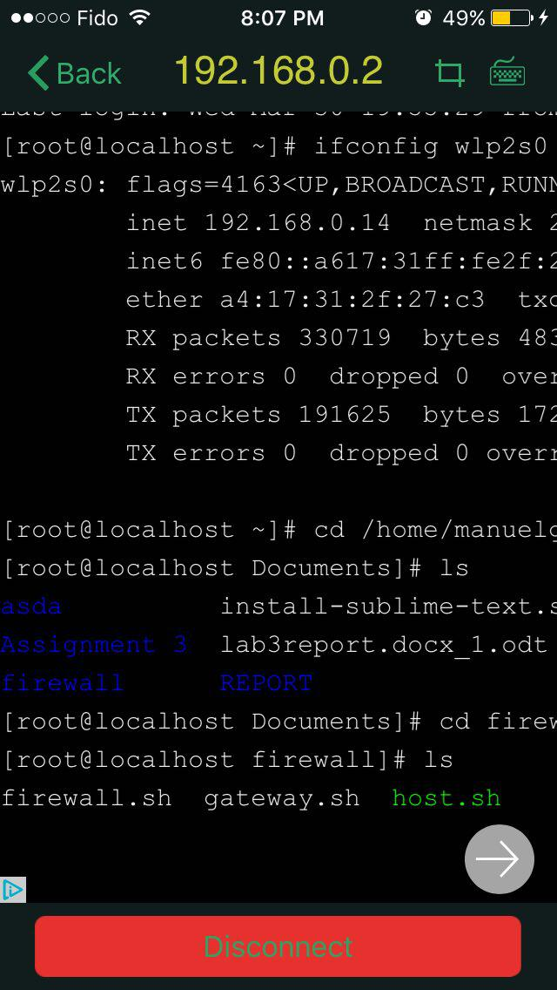

Figure 8

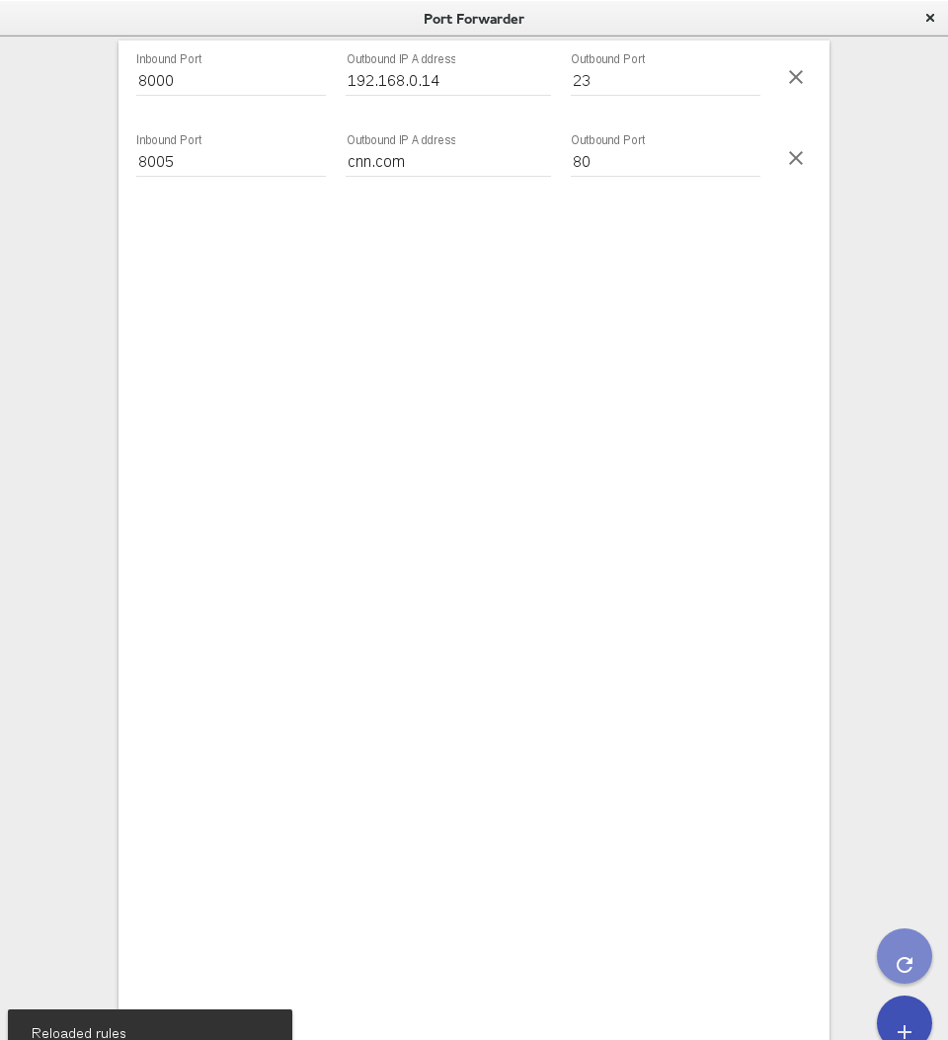

Figure 9



Figure 10

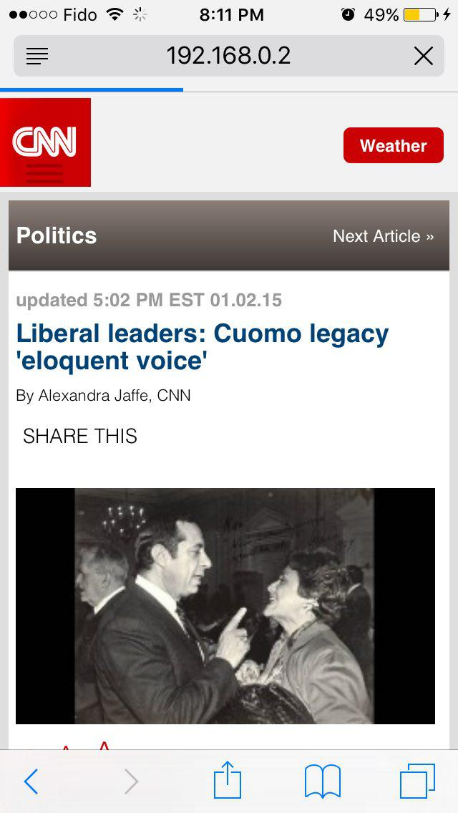

Figure 11

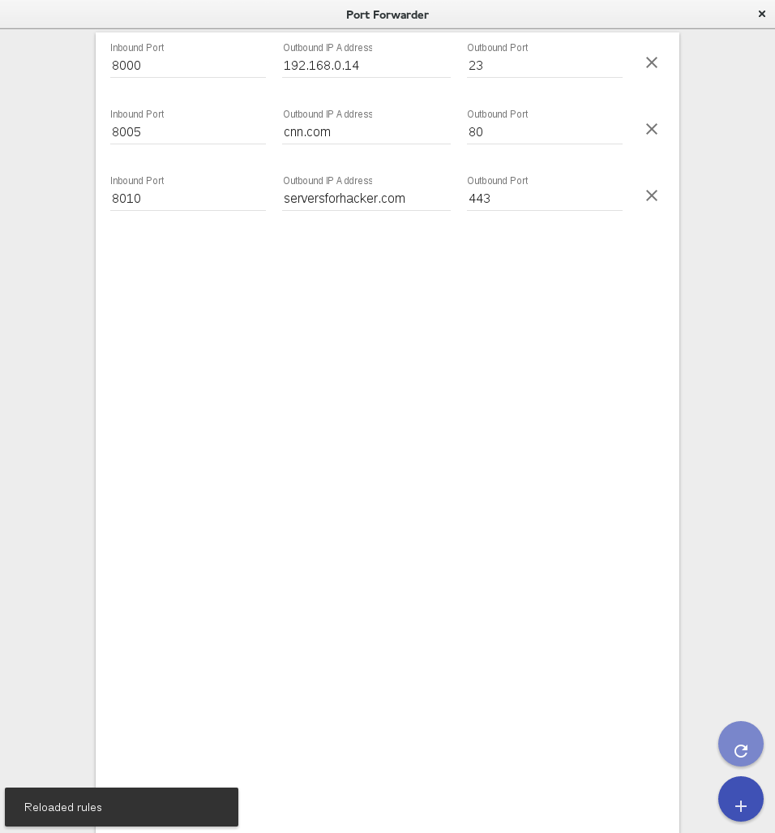

Figure 12

(typo on website removed ‘s’)

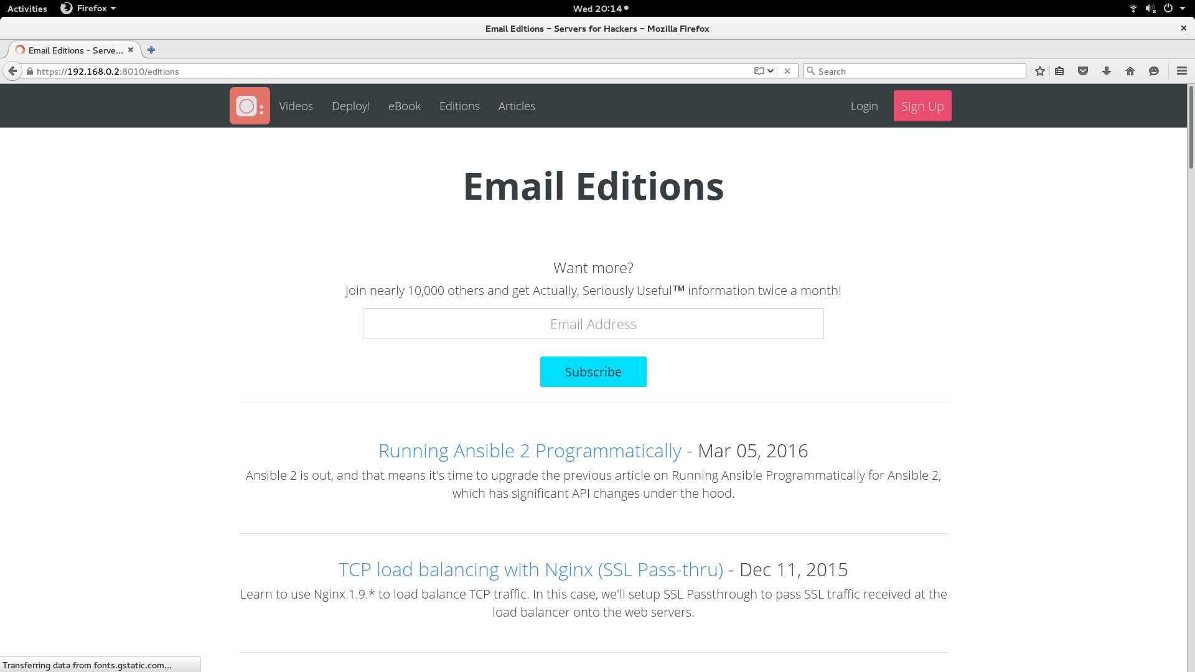

Figure 13

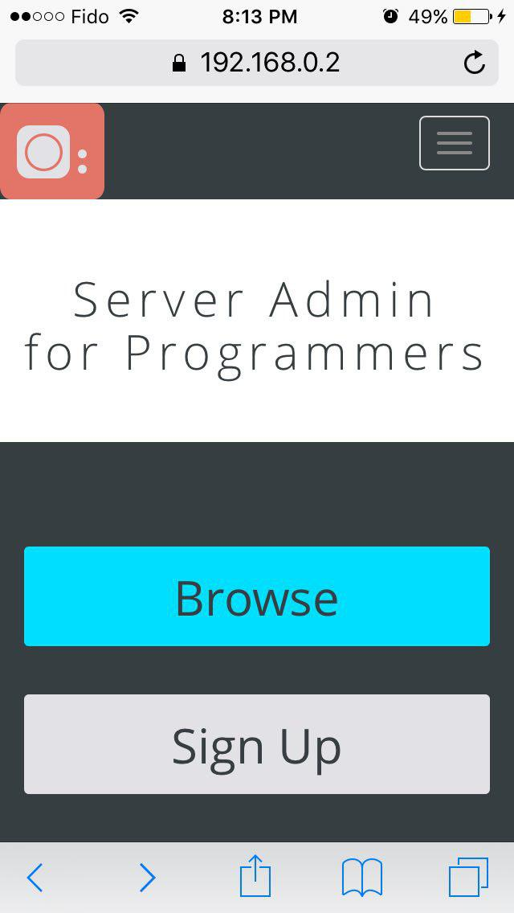

Figure 14

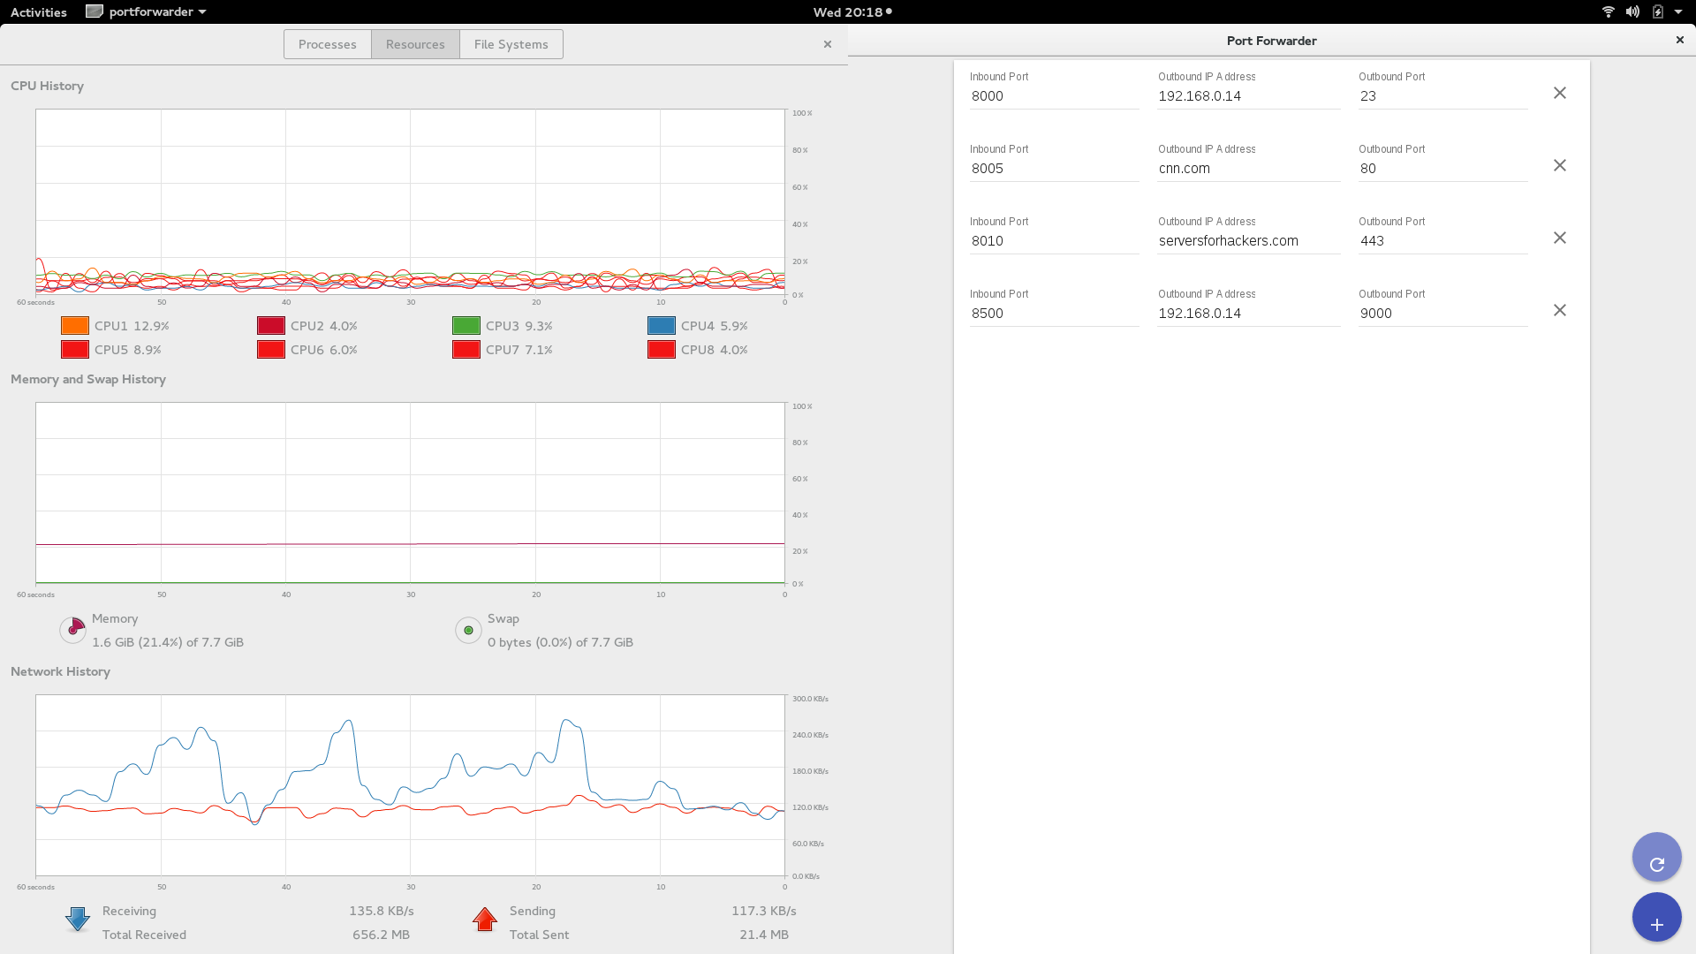

Figure 15

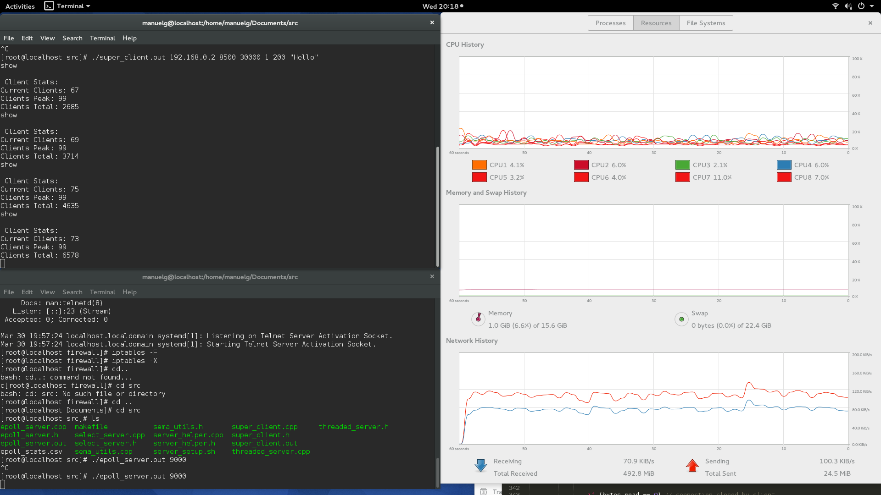

Figure 16